**TABLE create:**

CREATE TABLE Bugresistance (

StudentID int,

StudentName varchar(255),

City varchar(255),

PostalCode varchar(255),

INCOME varchar(255)

);

INSERT INTO Bugresistance (StudentID, StudentName, City, PostalCode, INCOME)

VALUES (101, 'Tahia', 'Noakhali', '4000', '10000'),

(102, 'Sharmin', 'Barisal', '4000', '10000'),

(103, 'Rakhi', 'Rajshahi', '4000', '10000'),

(104, 'Masud', 'Dhaka', '4000', '10000'),

(105, 'Rimi', 'Noakhali', '4000', '10000'),

(106, 'Emi', 'Dhaka', '4000', '10000'),

(107, 'Simi', 'Sylhet', '4000', '10000'),

(108, 'Rumi', 'Noakhali', '4000', '10000'),

(109, 'Sumi', 'Chittagong', '4000', '10000'),

(110, 'Mafi', 'Dhaka', '4000', '10000');

SELECT * FROM Bugresistance;

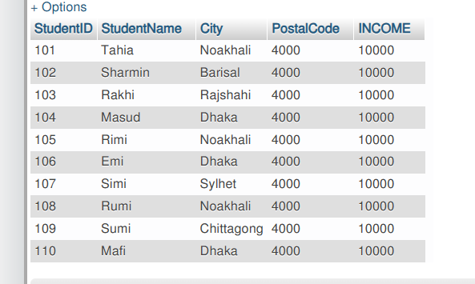

CREATE TABLE UNIVERSITY(

DEPTID VARCHAR(50),

STUDENTNAME VARCHAR(50)

);

INSERT INTO UNIVERSITY(DeptID, STUDENTNAME)VALUES

('1', 'Rakhi'),

('2', 'Tahia'),

('3', 'Sharminl'),

('4', 'Simi'),

('5', 'Rimi'),

('6', 'Jimi'),

('7', 'Rumi');

SELECT * FROM UNIVERSITY;

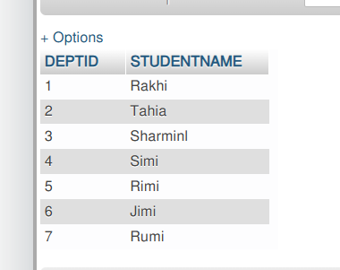

**INNER Join:**

[SELECT](http://localhost/phpmyadmin/url.php?url=https://dev.mysql.com/doc/refman/8.0/en/select.html) Bugresistance.StudentID, UNIVERSITY.STUDENTNAME, Bugresistance.City, UNIVERSITY.DEPTID, Bugresistance.INCOME FROM Bugresistance INNER JOIN University ON Bugresistance.StudentName=University.STUDENTNAME;

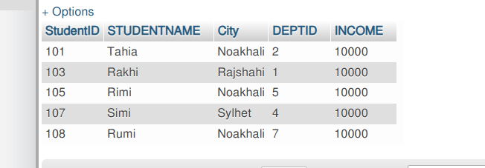

**LEFT JOIN:**

[SELECT](http://localhost/phpmyadmin/url.php?url=https://dev.mysql.com/doc/refman/8.0/en/select.html) Bugresistance.StudentID, UNIVERSITY.STUDENTNAME, Bugresistance.City, UNIVERSITY.DEPTID, Bugresistance.INCOME FROM Bugresistance LEFT JOIN University ON Bugresistance.StudentName=University.STUDENTNAME;

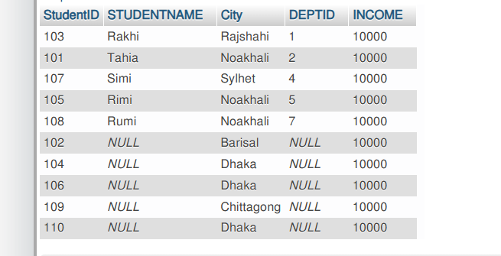

**RIGHT JOIN:**

[SELECT](http://localhost/phpmyadmin/url.php?url=https://dev.mysql.com/doc/refman/8.0/en/select.html) Bugresistance.StudentID, UNIVERSITY.STUDENTNAME, Bugresistance.City, UNIVERSITY.DEPTID, Bugresistance.INCOME FROM Bugresistance RIGHT JOIN University ON Bugresistance.StudentName=University.STUDENTNAME;

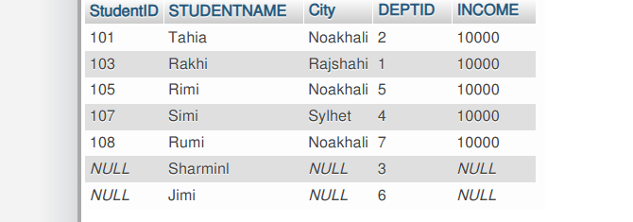

**FULL OUTER JOIN:**